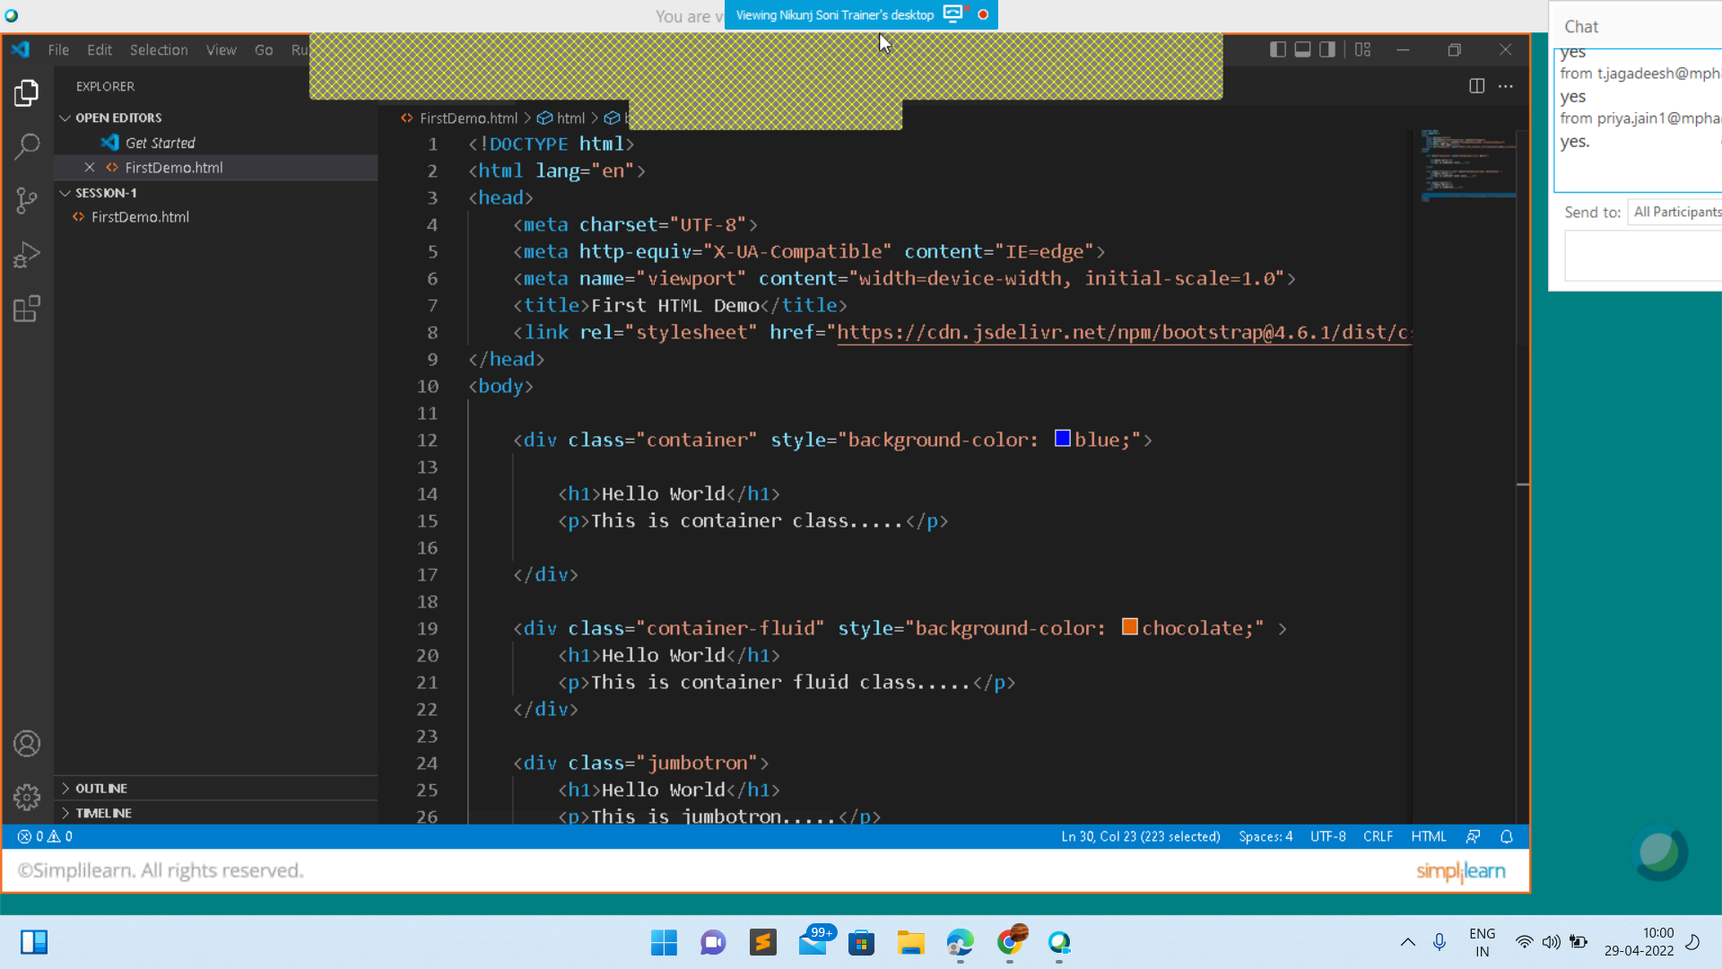

https://getbootstrap.com/docs/4.6/getting-started/introduction/

<https://code.visualstudio.com/>

<https://github.com/Nikunj-Java/Mphasis-Phase4-and-Phase5>

<https://github.com/Nikunj-Java/Mphasis-Phase4-and-Phase5/tree/main/Session-1>